# AblyStep

**Objective:**

It is used to publish notification on subscribe channel.

**Attributes:**

|  |  |
| --- | --- |
| **Attributes** | **Description** |
| channel_name | To enter the channel name |
| name | To enter the name |
| data | To enter message data |
| value_type | To select type as free marker template or handlebar |
| plugin_name | Used to connect with ably |

**Sample config.json:**

{

"workflows": [

{

"name": "Ably notification",

"id": "ably",

"trigger": "rest",

"expression": "ably",

"method": "GET",

"steps": [

{

"id": "1",

"type": "ably",

"plugin_name": "ably-message",

"value_type": "hb",

"name": "message title",

"data": "message data",

"channel_name": "sport",

"next": {

"success": "ably-succ",

"failure": "ably-fail"

}

}

]

}

],

"filters": [],

"server": {},

"plugins": [

{

"id": "10",

"api_key": "oybGjQ.Yv7tcg:4UrB37IRpda2JydY",

"type": "ably-plugin",

"name": "ably-message",

"version": "1.0"

}

]

}

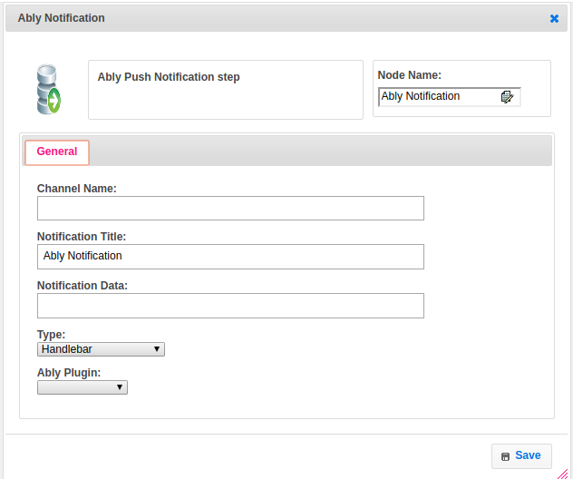

**Executor Description:**

In executor class first create a json object to send notification body data and send notification to the respective channel with message data and it will send the status based on response code. If any exception occur then set status to failure.